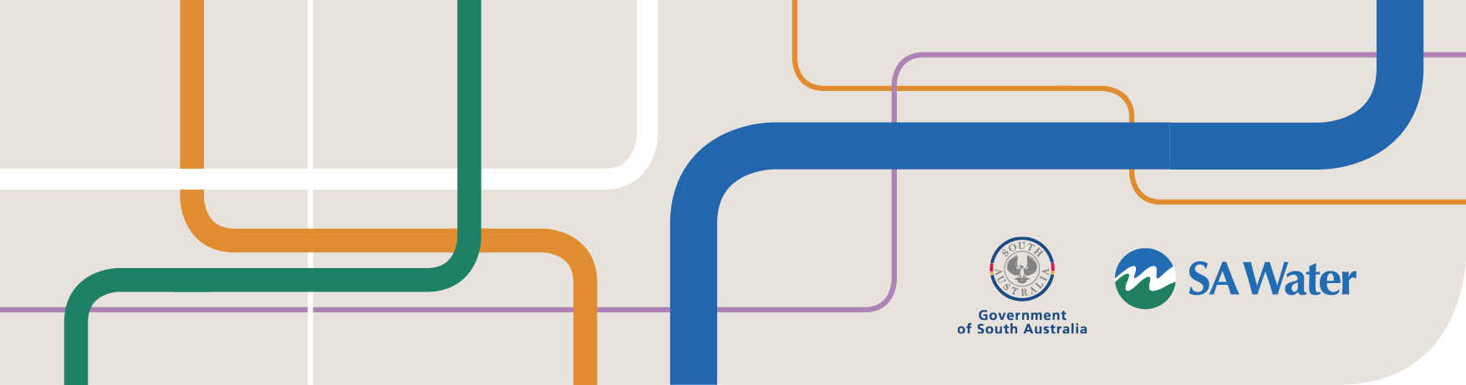

**Advice of Proposed Building**

Notification of Proposed Buildings/Alterations

This advice must be completed where;

* Water and/or Wastewater connection is required
* Trade Waste drainage is required for industrial, business, trade or manufacturing processes
* Building over a SA Water easement

**Applicant details**

Name:       Email:

Postal Address:

Phone:       Mobile:       Fax:

**Site address**

Property Owner:       Email:

Address:

Phone:       Mobile:       Fax:

Account Number:       Meter Number:

(10 digit number)

**Connection requirements**

If a new connection/s is required, complete a [Water/Wastewater Connection Application](http://www.sawater.com.au/__data/assets/pdf_file/0016/16153/WaterSewerAppnForm.pdf) and send the application to [cc@sawater.com.au](mailto:cc@sawater.com.au)

**Please ensure the following information is attached with this application**

* A **site plan** showing nearby streets, house/lot number and sanitary fixtures.
* A **plumbing and drainage plan** is also required in the following instances:
  + Commercial/industrial developments including trade waste sites
  + Where a new or altered wastewater connection is required
  + Private pumping applications including swimming pool discharges

**Further information**

* If you propose to build over a SA Water easement, please refer to our [External Easements – Options for Obtaining External Easements](http://www.sawater.com.au/__data/assets/pdf_file/0015/7071/EncroachmentoverEasement.pdf) fact sheet.

**How to submit this application – Please include your plans with this application**

**NB: plans must not be larger than A3 in size**

**Email** [bpa@sawater.com.au](mailto:bpa@sawater.com.au)

**Mail** Customer Technical Services

GPO Box 1751, Adelaide SA 5001

Date Submitted by Applicant:      /      /      Date Received by SA Water:      /      /