Source to Contract

Supplier Portal Handbook

Version: 1.0
Date: 08/05/2024
Status: Final
Confidentiality: OFFICIAL

© 2024 SA Water Corporation. All rights reserved. This document may contain confidential information of SA Water Corporation. Disclosure or dissemination to unauthorised individuals is strictly prohibited. Uncontrolled when printed or downloaded.

Contents
1 Purpose of this document 1
2 About us 1
3 What we do 1
4 How we do it 2
5 Navigating the portal 2
5.1 Login page 3
5.2 Navigation 4
5.2.1 Menu 4
6 Registering as a supplier 6
6.1 Initial registration 7
6.2 Full registration 9
7 Information Change Request 15
7.1 Information change request 15
8 Sourcing Events 17
9 Contract Management 18
9.1 Contract document 18
9.2 Price list update 21
9.3 Performance Evaluation 22
9.4 Collaboration Plan 23
10 Frequently Asked Questions 26

Purpose of this document
To provide instructions on how:
- Existing and potential suppliers can register on our portal.
- Existing suppliers who have registered, can maintain their company information, view and respond to sourcing events and, where successful, implement and manage resulting contractual agreements on the portal.

This document consists of 5 sections and covers the key activities to be undertaken by suppliers in the portal:
- Supplier registration – provides step-by-step instructions on registering.
- Supplier information change request – provides a step-by-step process to change request/modify company information (such as; change in supplier address, contact details, emails, change or update bank details, name, reactivate supplier).
- Sourcing event – outlines how suppliers can locate publicly announced procurement opportunities and submit a proposal in response.
- Contract management - outlines how you can review, request changes, execute contractual agreements, perform a price list update, evaluate and use the collaboration plan function.
- FAQs – some of the most frequently asked questions when registering and using the portal.

About us
We are a successful, modern water utility that is owned by the Government of South Australia, employing more than 1,500 people and operating more than $14 billion of assets, delivering essential water and sewerage services to more than 1.8 million South Australians.
We are the driest state, with vast distances, prolonged drought and sites
and locations from Ceduna through to Port Augusta, the Anangu Pitjantjatjara Yankunytjatjara (APY) Lands, across to the Riverland and down to
Mount Gambier.
Our products and services mean that we have several independent regulators and comply with major pieces of legislation and obligations and have several management systems in place, such as the Drinking Water Management System (DWQMS), Environmental Management System (EMS) and Safety Management System, to manage risk, maintain compliance and improve business efficiency.

What we do
- Supply water.
- Remove sewage from home and businesses.
- Treat sewage and wastewater.
- Recycle some wastewater.
We maintain and operate over $14 billion worth of assets that includes 16 reservoirs (10 metropolitan and 6 regional), 44 water treatment plants, 29 wastewater treatment plants and over 36,000 kilometres of water and sewerage pipework.

How we do it
We have a strategic plan that sets our direction and influences how we make decisions. Feedback from customers is used to improve our services and we use this and market research to guide the decisions we make.
We care about the future of South Australia and are committed to sustainability, considering the long-term future of our state's economy, society and environment. The principles that we consider in our decision making include:
- Economic efficiency – We will be as efficient and effective as possible, balancing affordability with great service delivery.
- Environmental performance – We will work to reduce our environmental footprint and improve our climate resilience.
- Social responsibility – We will apply our skills, assets and services for the greater benefit of the state and people of South Australia.

Navigating the portal
The following pages provide an overview of how to navigate the portal, including an overview of some features that are common across the portal.
Items covered in this section:
- Key components of the login page.
- Information on general navigation buttons which are available across the platform.
- An overview of the drop-down menus.
- Features of the homepage.

Login page
When clicking the link to the portal, you will land on a login page.
- The left hand side of the screen displays an overview of the supplier portal.
- If you have login details, please enter them here. You can retrieve forgotten passwords here.
- Helpdesk details are displayed here.
- Register here if you are not registered on the portal.
- Publicly available tenders will be displayed here. To submit a proposal, you will need to complete initial registration found here.

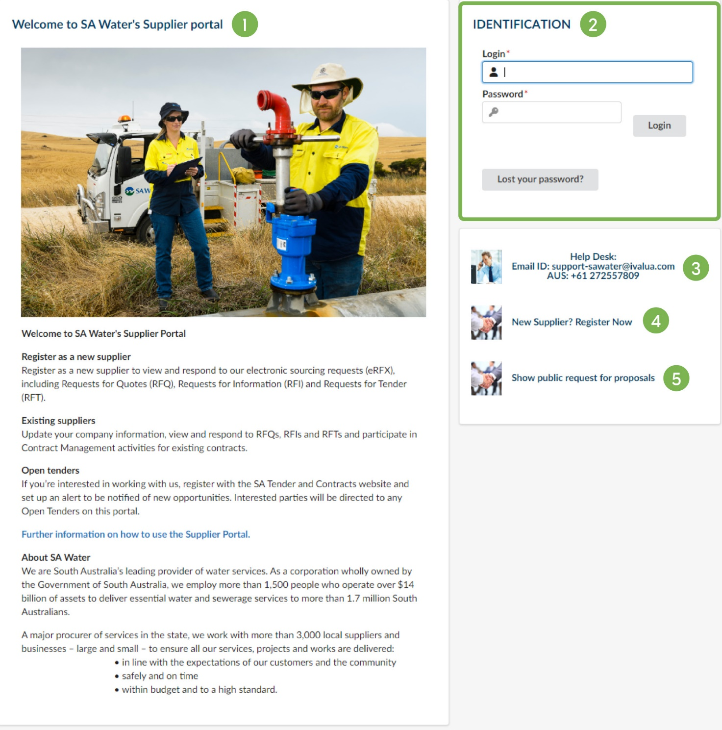

Navigation
The home page will display once logged in. This page displays a snapshot of activities and actions assigned to your company.
- At any time, to return to the homepage, click the SA Water logo in the top left corner.
- To go back one page, click the Back icon.
- To view the last 15 pages visited, click the Clock icon. A drop-down menu will appear. Click any page in the list to navigate back.
- To setup favourites, click the Star icon, name the page (default is number) and click Add Page. When adding a search page as a favourite, all the selected search filters will be saved with the favourite. Once created, the favourite can be recalled using the same star icon.

Menu

Menu name | Description
- General information | Your company profile which includes address, contacts, documents, and certifications as required by us.
- Sourcing | All open and completed sourcing events that have been published in the portal.
- Contracts | All agreements between your company and us managed in the portal.
- Catalogues | Information about all line Items included in signed agreements.
- Performance | Performance evaluations and collaboration plans.
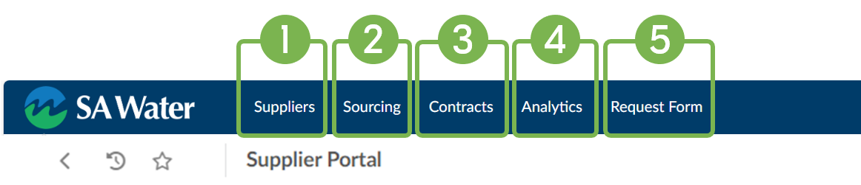

Menu name | Description
- Company Profile | Takes you to your company profile to view and manage your company details.
- Announcement | General announcements from us.
- Onboarding Process | Onboarding process, checklist and relative progress.
- Validations | Open approvals or tasks to be completed for sourcing events and contracts.
- Dashboard | Request for proposals/sourcing events in progress and current number of contracts.
- Review Client | Provide feedback on working with us.

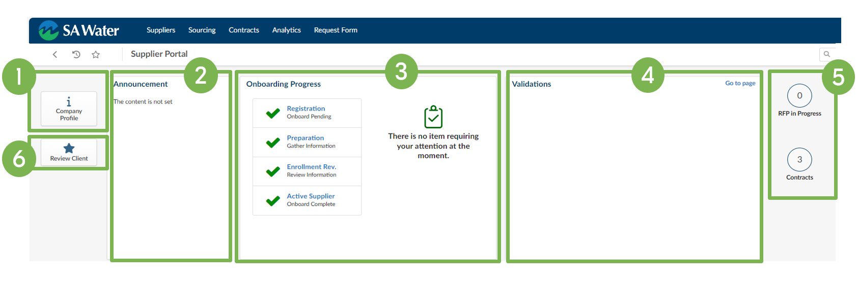

Registering as a supplier
Organisations invited to participate in a tender response and seeking to register as a supplier with us will need to complete self registration. This ensures authenticated and authorised suppliers are granted access to the portal, which is integral for maintaining the security and efficiency of our procurement operations.
Self registration is necessary to gain access to the portal to register and maintain company information, participate in sourcing events, and manage existing contracts. It is an essential step that enables you to engage with our procurement processes in a streamlined and transparent manner.
Registering will also allow suppliers who have already participated and been successful in an off-line sourcing process, to provide the required company information to facilitate the engagement process.
Initial registration will allow you to access and respond to sourcing events or for suppliers who have already participated and been successful in an off-line sourcing process to commence initial registration and facilitate the engagement process. Steps A and B of the below initial registration process overview are outlined here.
Full registration is required if your response is successful, and a trading relationship is to be implemented with your organisation company and SA Water. Steps C and D of full registration are outlined here.

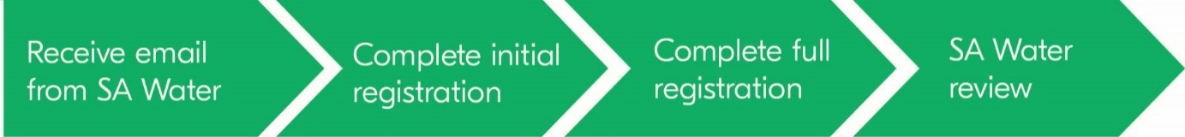

Initial registration
- To access supplier self registration click on the link that you received via email.
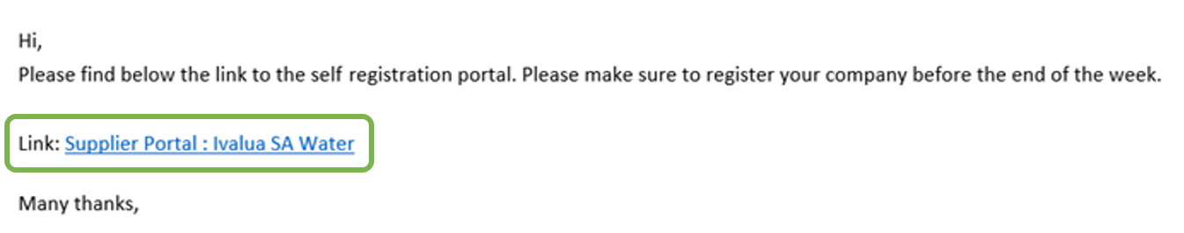

- Once you are on the source to contract supplier portal log-in page, click on New Supplier? Register Now as illustrated below.
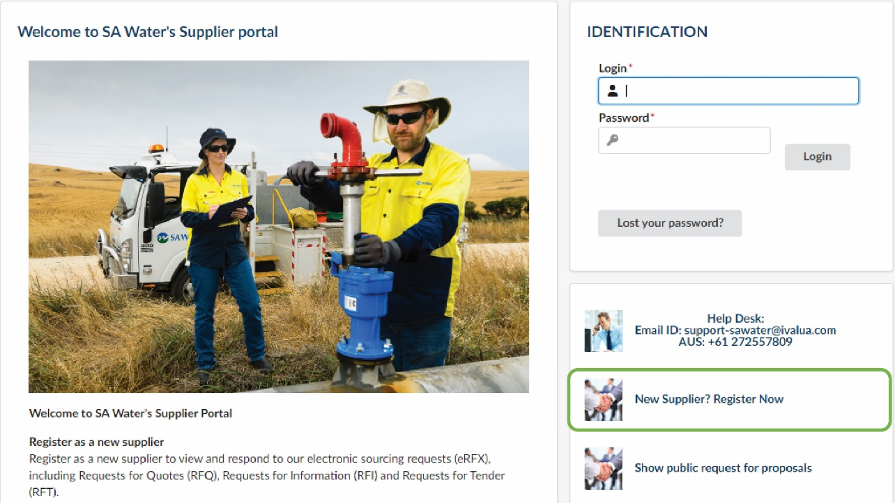

- Under the Security Control section, complete the Security Control section by typing in the characters shown and clicking Submit.
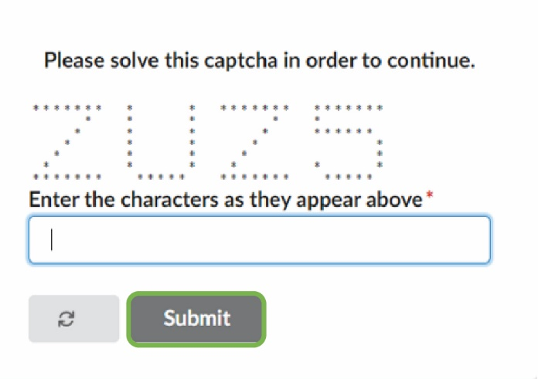

- Complete all the required fields (*) within the company information, contact information, and additional information sections:
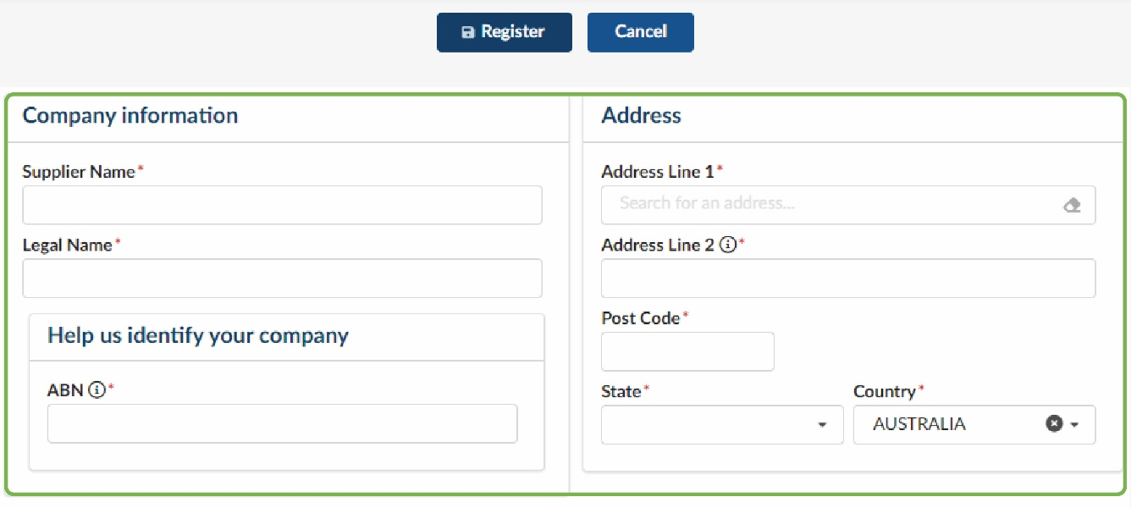
- Under commodities, please select the relevant industry category that relates closest to your service or goods offering?
Under commodities click See All, and then use the manual view to expand the hierarchy or use the Keywords search to locate the closest industry category.
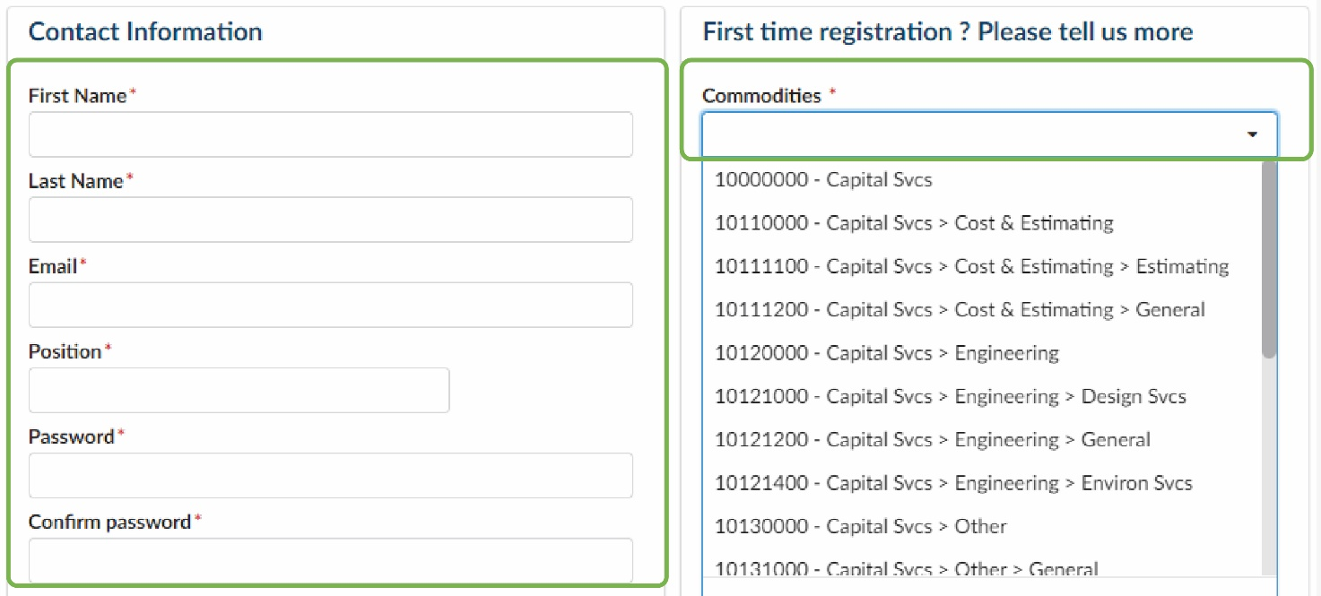

- After completing all required fields on the registration page, click on Register on the top of the page.
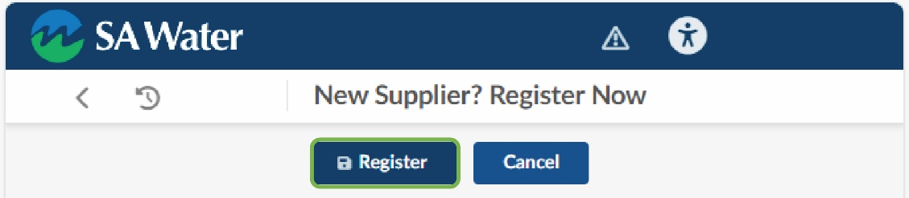

- Click on Go Back to login page.
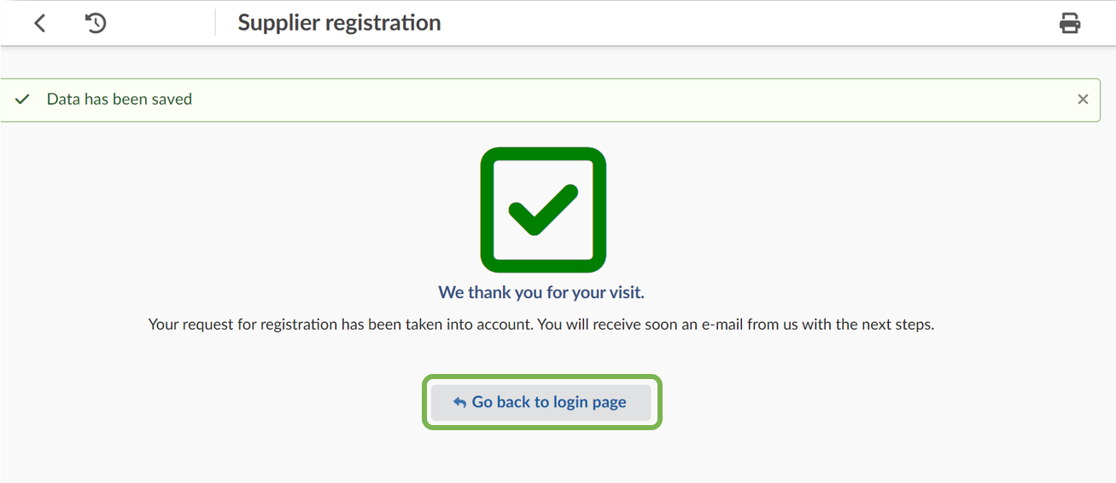

Full registration
- After completing the initial registration, you are now able to access your account by:
Logging in as the new supplier by entering the email address and password used to register and click Login.
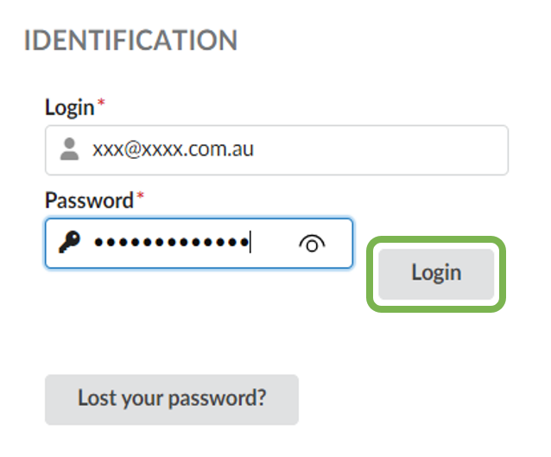
- Accept the General Terms and Conditions and click Acknowledge.
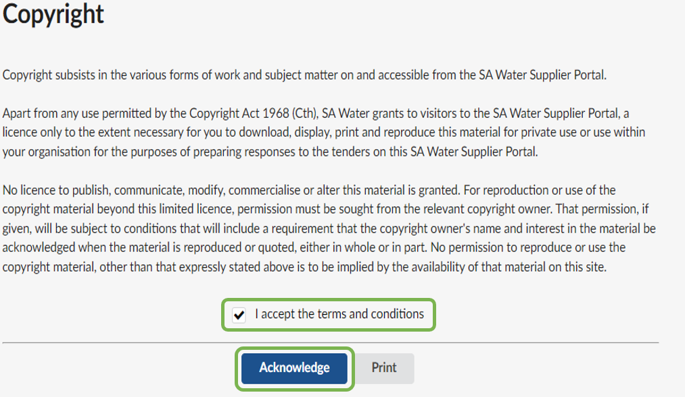

- To update Company Profile, navigate to the General Info. menu and select Company Profile from the drop-down menu. You can access the Company Profile directly via the homepage.
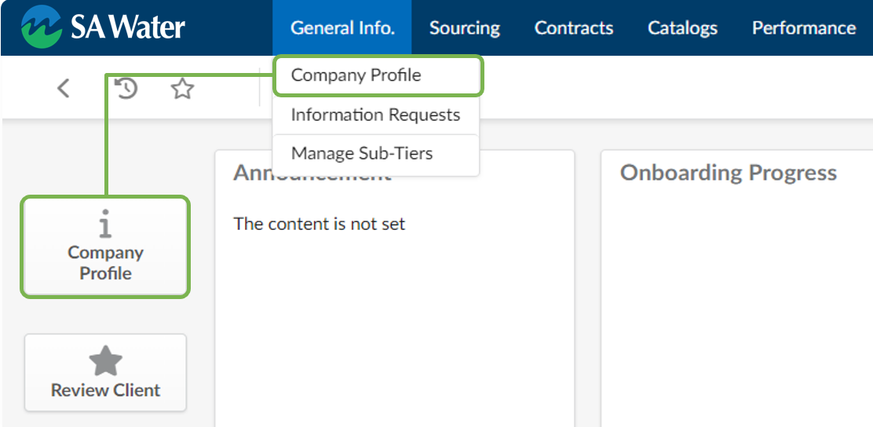
- Review data populated on the Company Information tab from the self registration form. Populate any additional fields and click Save.
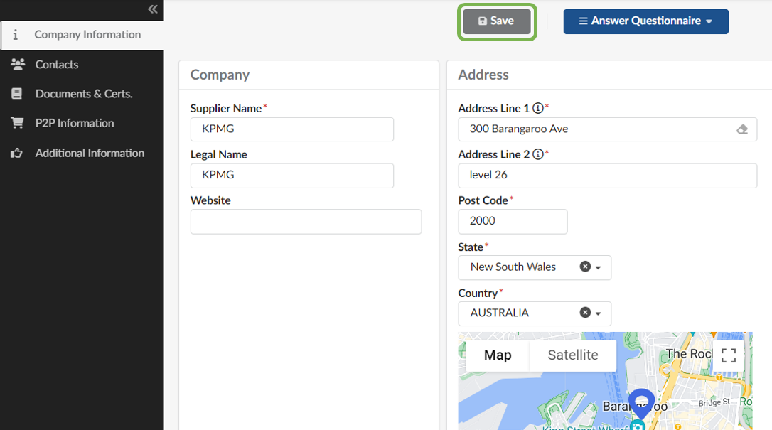

- Navigate to the Contacts tab.
  - Update the Role(s) column by selecting all that apply. At least one contact must be added for order and payment contact roles. Multiple roles can be allocated to a single contact.
  - Add other contacts from your company by clicking the + Create Contact button.
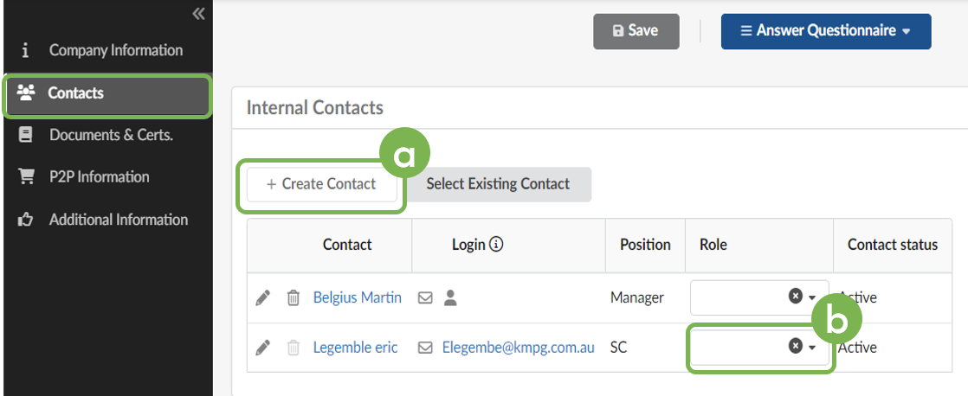

- Enter in the contact details and click Save or Save and Close at the top of the window.
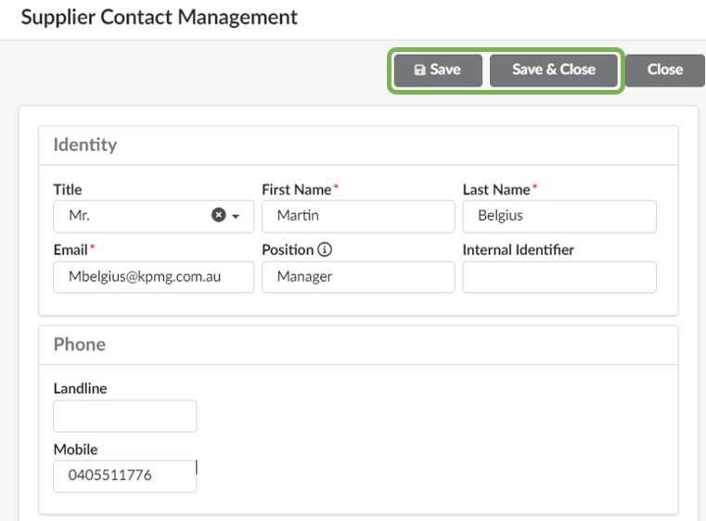
- To invite the recently added contact to the portal, click the envelope icon.
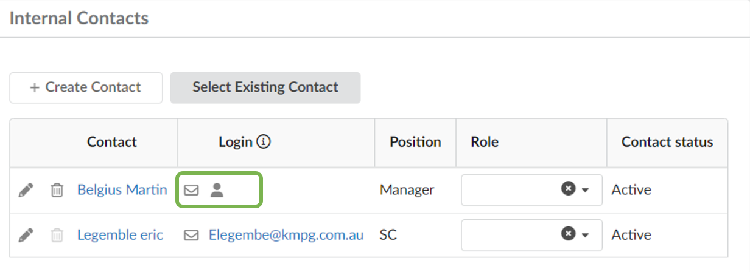
- Amend the email content as required and click Send Invitation at the top of the window. Click the X at the right corner to close the screen. Save all changes before navigating to the next page.
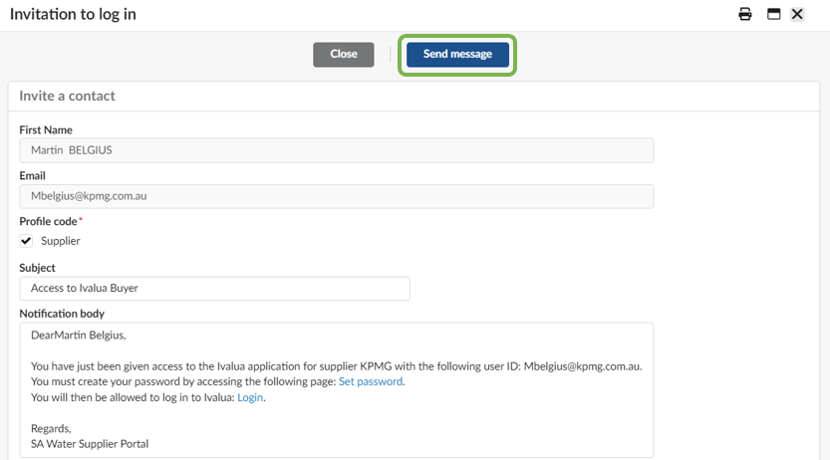
- Navigate to the Documents & Certs. Tab. Click Bank Verification to add a banking document. Acceptable forms are banking details recorded on company or bank letterhead paper, banking statements.
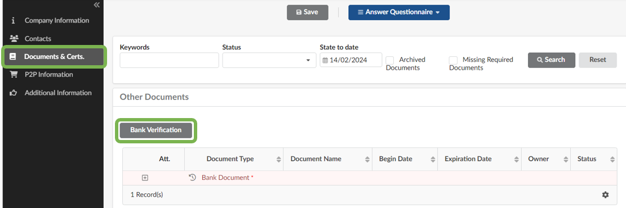
- Select Other Documents / Bank Document under Document Type. Populate required (*) data fields and upload your bank verification document by clicking or dragging the Document button. Click Save or Save and Close at the top of the window.
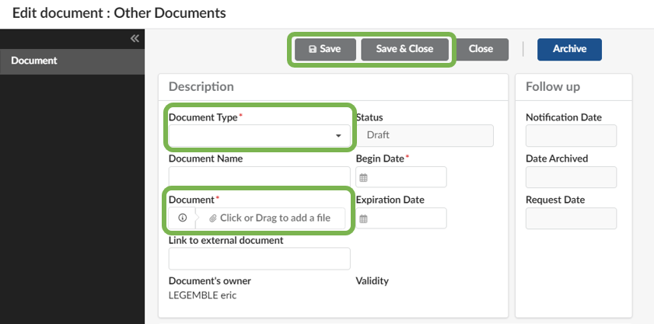
- In the event a bank document is already uploaded and needs to be replaced:
  - Click the pencil icon.
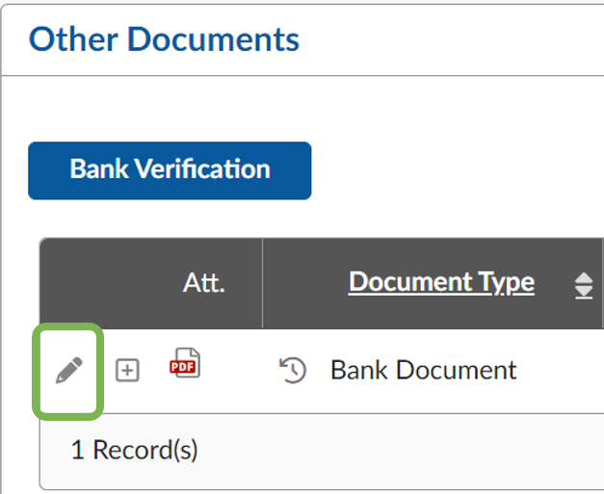
  - Click archive and repeat steps 9 and 10 to upload new document.
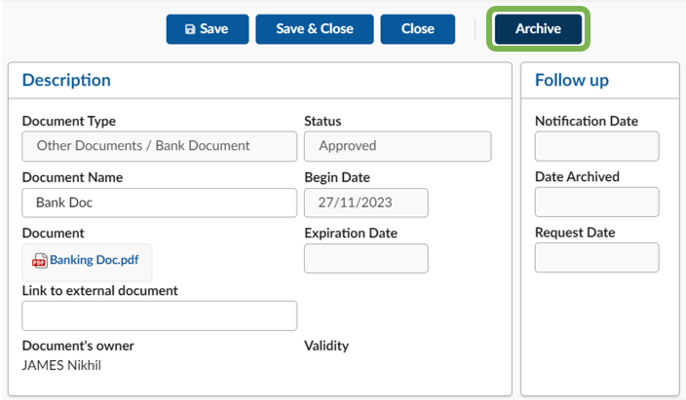

- Navigate to the P2P Information tab. Click +Add Banking Information.
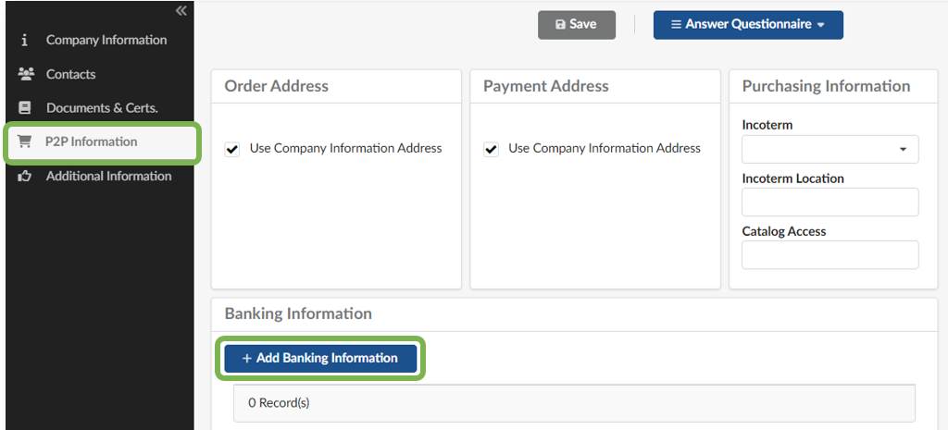
- Populate required (*) data fields and click Save.
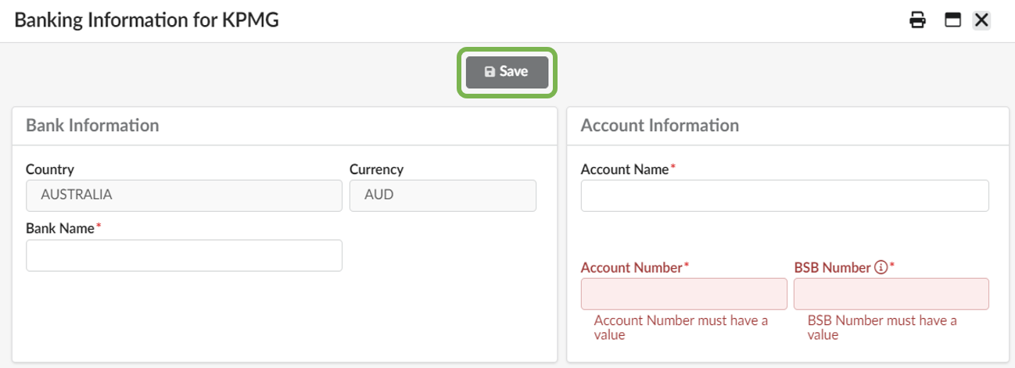
- Navigate to Additional Information tab.
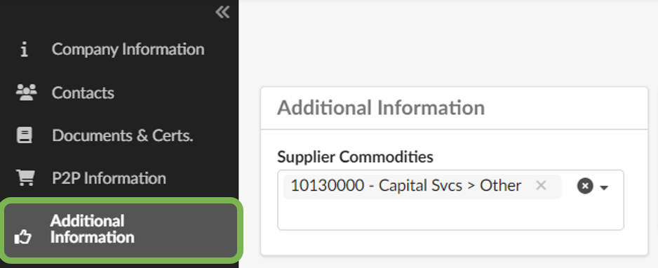
- Review data populated on the Supplier Commodities field and add additional commodity categories as required. Click See All to view and search all available commodities.
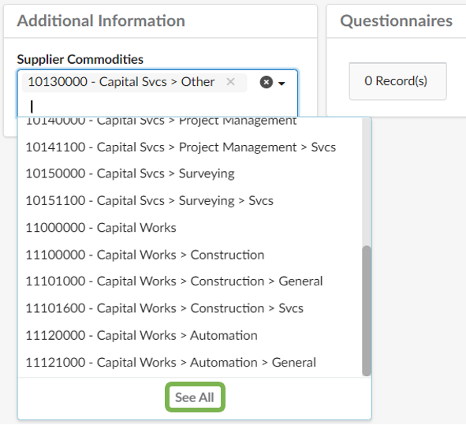
- Once all information is completed click Submit for Activation.
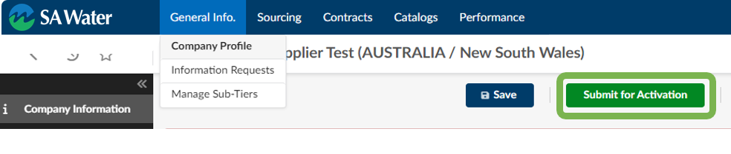
Thank you! We will now review the details and documentation provided.

Information Change Request

The Supplier Information Change Request process is initiated when a change to your information is required. Keeping your company profile up to date is important and ensures that we have current and accurate information.
You should submit an information change request if your office address or bank details have changed. Only one contact in your company can have a supplier administration role, which is required to perform a change request. The administration contact can assign responsibility to another contact and cease to be the supplier administrator.
We may at any time invite you to review and update your company details.
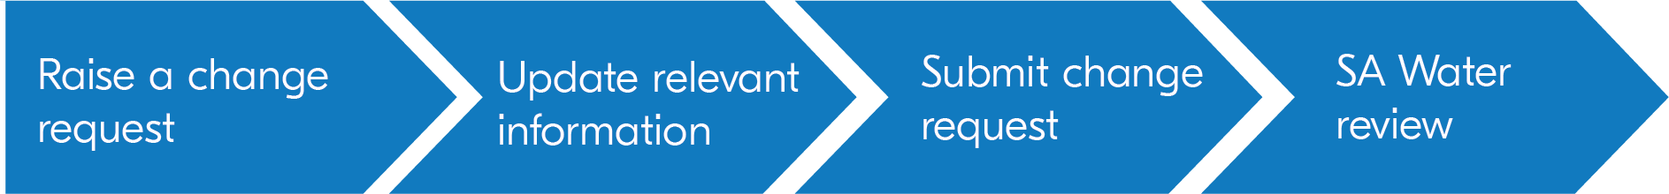

Information change request
- Update Company Profile by navigating to the General Information menu and select Company Profile from the drop down menu or the homepage Company Profile quick access button.
- If there is a change request in progress, you will not be able to raise a new request until this has been approved and completed.
- To make changes to your Company Information, click Request Information Change.
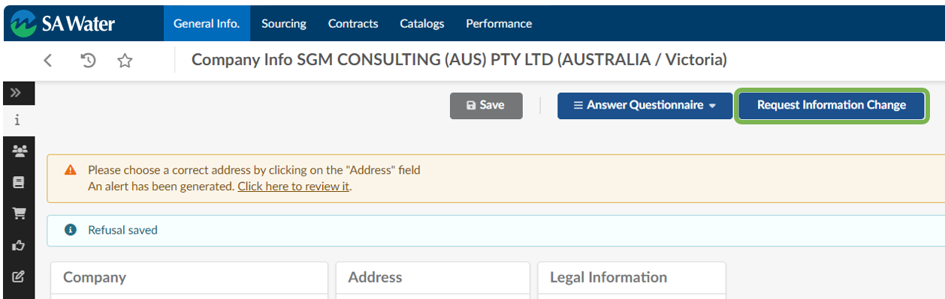
- Make appropriate changes and explain them in ‘Reason for Change Request text box that is now visible.
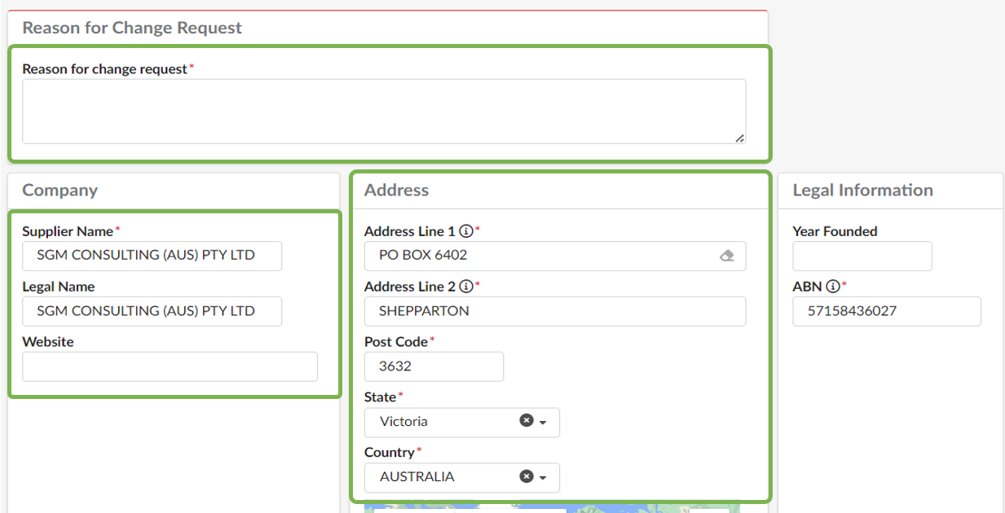
- Navigate to the P2P tab
- Click the pencil icon to update your bank details.
- Click Save and Approve. This will trigger a notification and we will approve changes.
Update bank documents at the same time as changing banking details.
Refer to steps 9-10 of Full Registration.
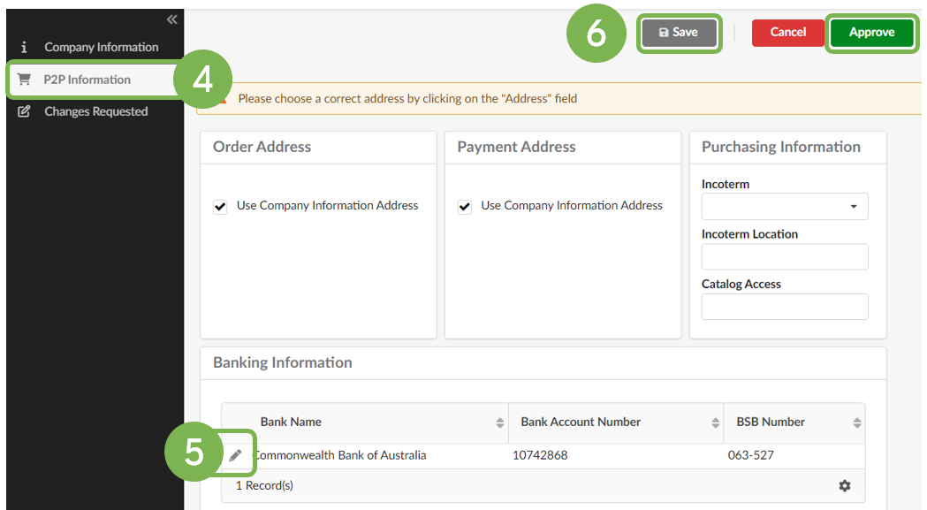

Sourcing Events

We will publish public Sourcing Events on the portal where you can respond to these opportunities. Not every sourcing event will be published on the portal, simple request for tenders and purchase orders are conducted outside this system.
- If already registered (Initial or full registration) on the portal, you will be able to view and participate in public sourcing events.
- If not yet registered, you will be required to complete initial self registration, outlined here to access and participate in sourcing events.
- As a South Australian Government entity, policy requires us to publish qualifying sourcing events on SA Tenders & Contracts where the link will be made available in published information. We require all responses to be submitted via the portal.

Note: Proposals must only be submitted electronically via the SA Water Supplier Portal. Please ensure that you leave adequate time to submit your online proposal prior to the closing date and time. For further information on how to submit your proposal, a separate reference guide is provided with each published tender. If you experience any technical issues or require functional support, please email SourcetoContract@sawater.com.au.

Contract Management
If you have succeeded in the tender process, you can review proposed contractual agreements, request modifications if necessary, and sign and finalise contracts.
Ongoing management of contracts is also covered in this section.
The following pages provide a step-by-step guide on how to proceed with this process.

Contract document
- To commence the contract document
  - click Pending Validations in the Notifications section of the homepage,
  - or Click on pencil icon next to the relevant item in the Validations list of the homepage,
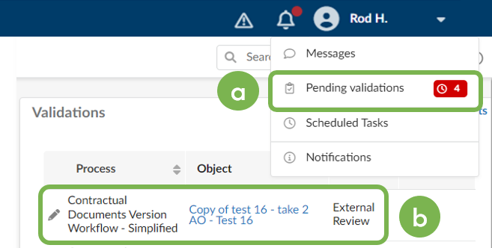
  - or if the item is not visible, click Go to page.
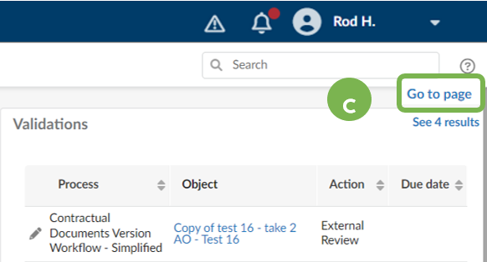
- Click the pencil icon to open the respective item requiring action.
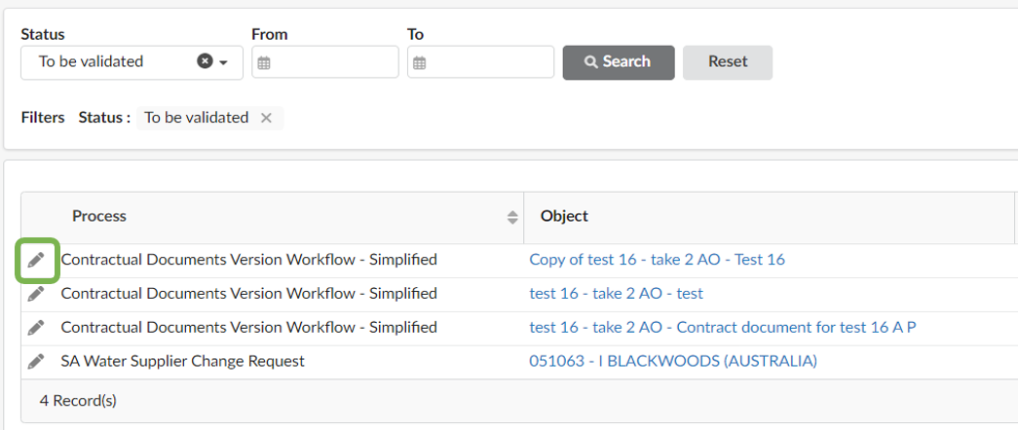
- Click Edit Document to open the contract in Word or Scroll down to access the preview of the contract document
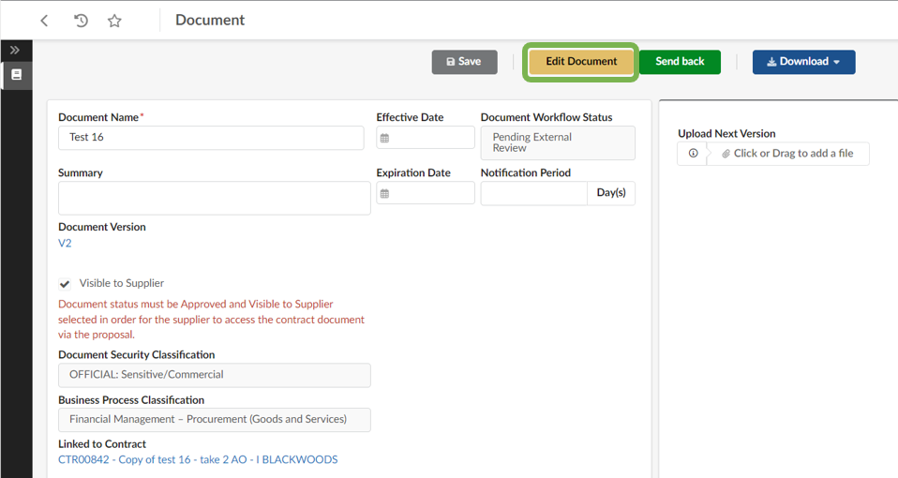
- When opened in Word, click Enable Content button to edit.
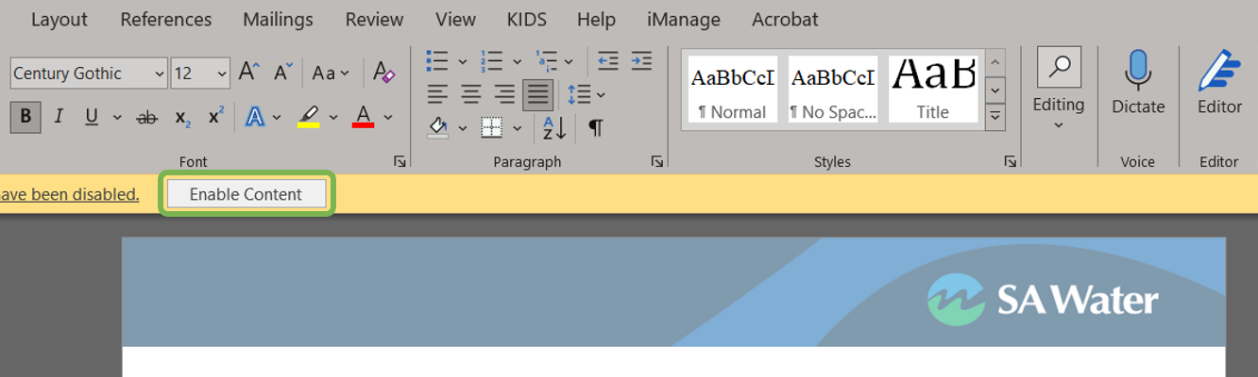
- Click the close icon (x).
- Click Save. Your changes will be saved to a new version of the document in the portal.
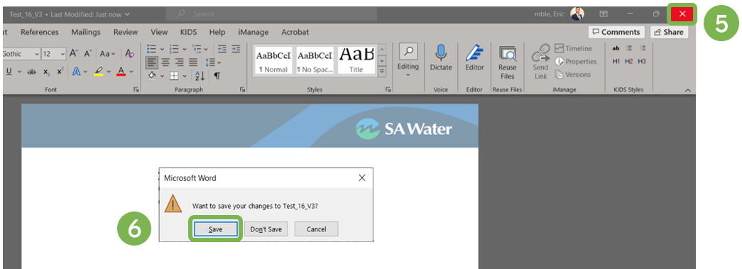
- Use Compare Version in the top right of the preview pane to compare any two versions of a document by selecting in the drop-down menu.
- Enter the versions to compare and click Compare in Word.
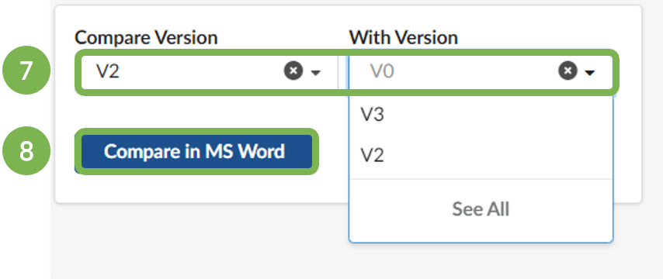
- Click the Review tab.
- Click on Reviewing.
- Modification summary will appear on the side.
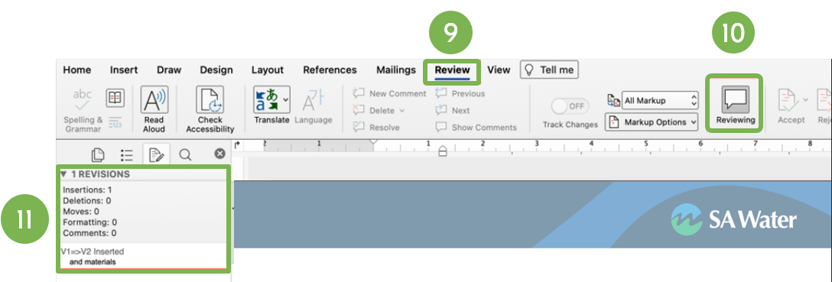
- Click the close icon (X).
- Click Save.

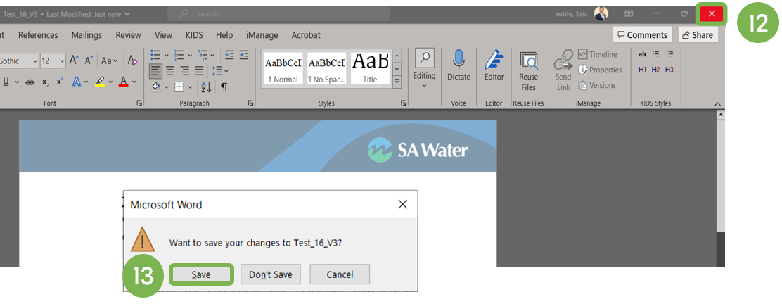
- If no other changes are required, click Send Back for review.
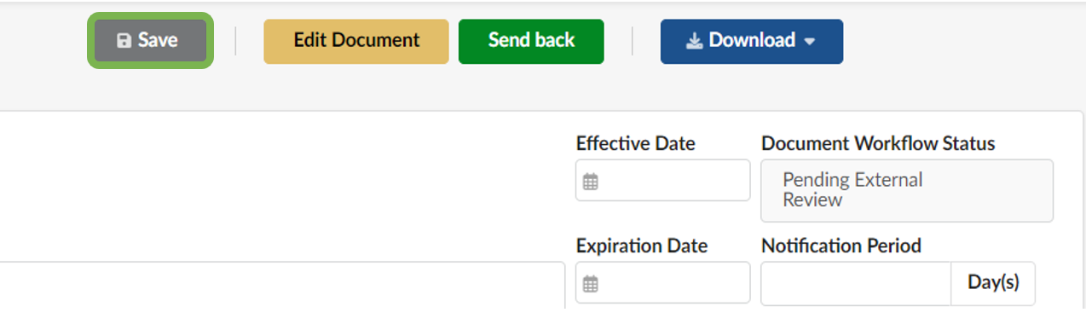
We will review your changes and may send further updates for your review.
Once all terms are agreed and the contract is finalised, the contract document will be sent to you for signature via Adobe Sign.
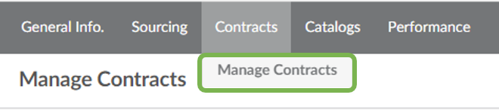
Once signed by all parties, the contract documents and details will be available to view in Manage Contracts area of the portal (accessible via the Contracts menu).

Price list update
If a contract pricelist review is required, we will create a price list update in the portal. You will be able to find this request on your homepage under Validations or under Manage Proposals under the Sourcing menu.
- Click the pencil icon to open.
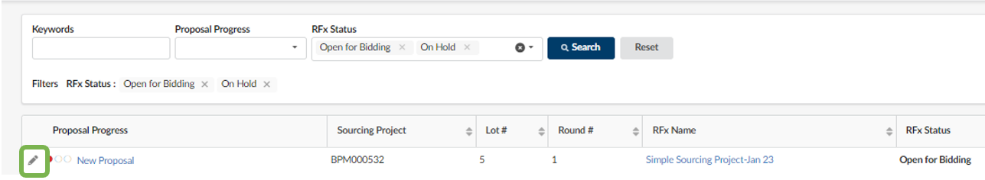
- Upon opening the items tab, you will be able to add updated pricing and delivery dates.
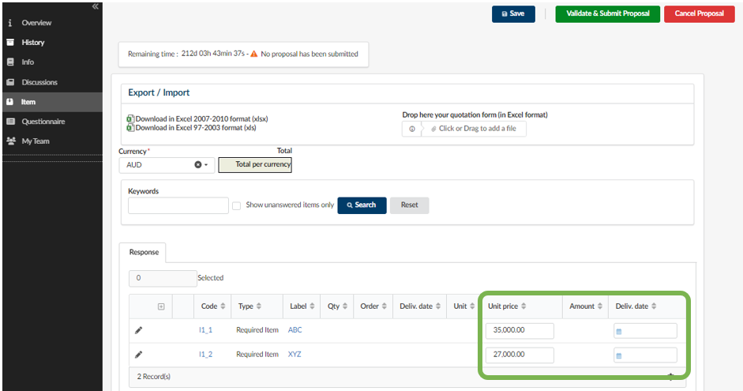
- Once all fields are complete, click Validate & Submit Proposal in the top righthand corner of the page.
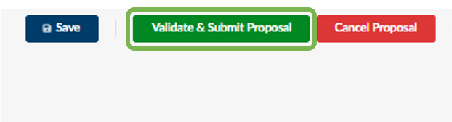
- Our contract manager will review the submitted information and may contact you to discuss any updates. Once pricing is agreed, it will be accepted and reflected in the Catalog area of the portal.

Performance Evaluation
- At any time, we may create an evaluation campaign for your attention. You can answer it by entering the Performance Evaluations menu.
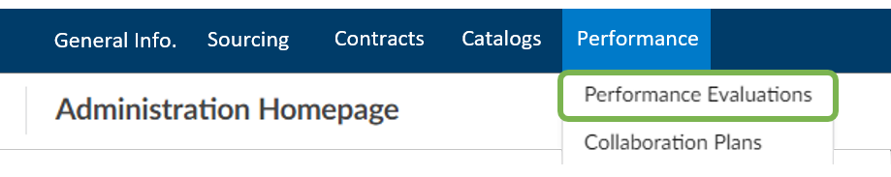
- Open the relevant campaign by clicking the pencil.
- Click on Answer Questionnaire.
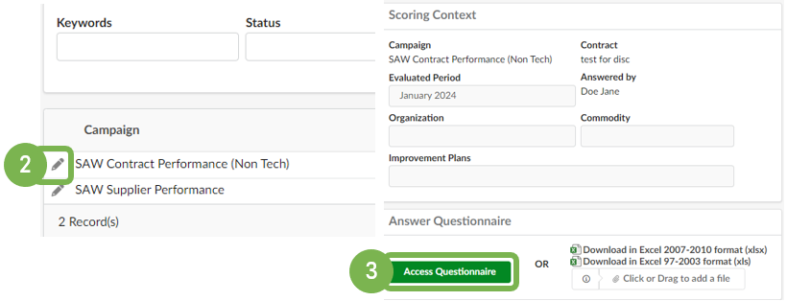
- Respond to all questions listed in the questionnaire.
- Repeat this process for all tabs listed on the side.
- When all questions and tabs are completed, click Submit.
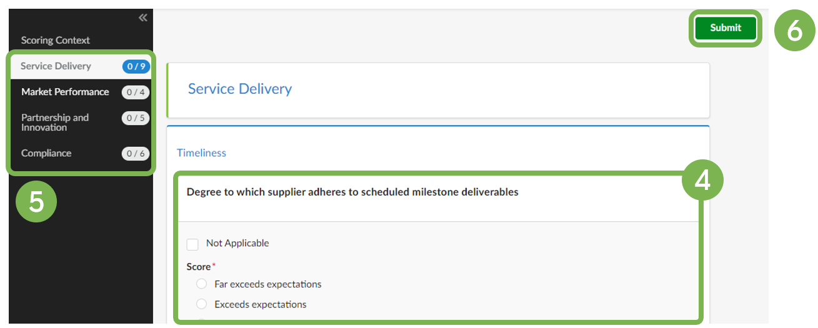
- Click OK to confirm.
- A confirmation message will appear to validate the successful submission.
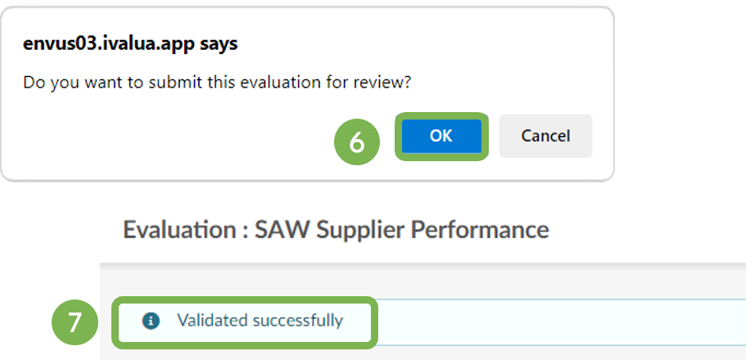

Collaboration Plan
- We may create a collaboration plan to address any issues or projects which are to be managed collaboratively between us and your company. When we create a collaboration plan for your attention, you can see your collaboration plan by navigating to the Collaboration Plans page found under the Performance menu.
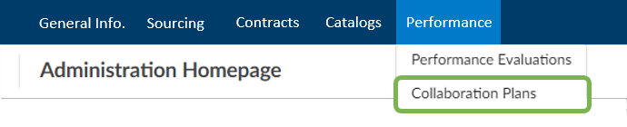

- Click the pencil to open the relevant plan.
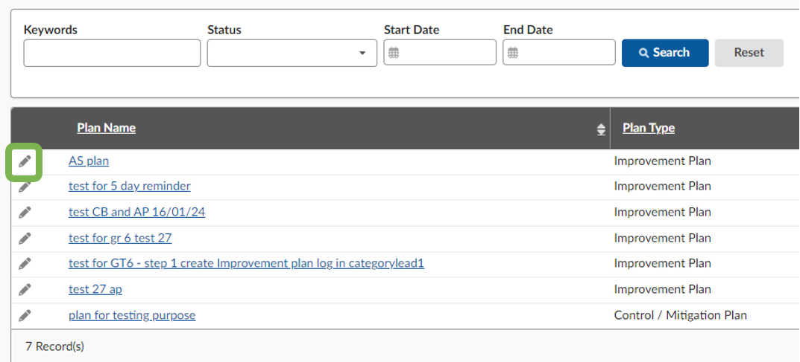
- When entering this menu, 3 tabs are displayed
(General Information Team & Tasks, and Workflow).
  - In General you can add comments and documents.
  - Send to a contact by using the drop-down menu.
  - Click Save once completed.
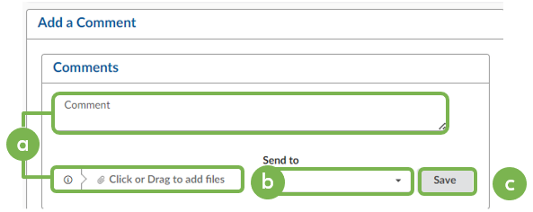
- In the Tasks List and Timing section you can add tasks which will be part of the plan by clicking on Add a Task.
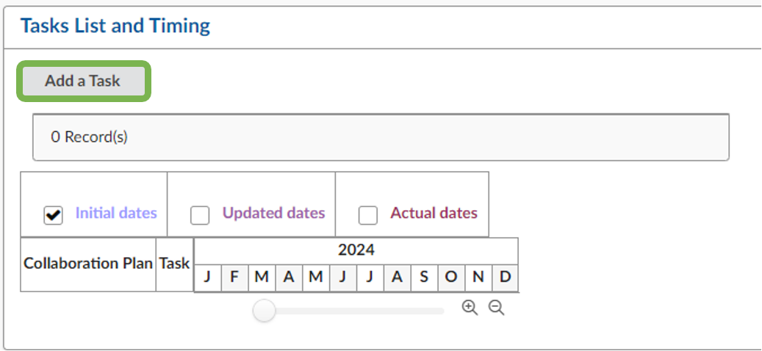

- Fill in the relevant information making sure all required fields (*) are completed.
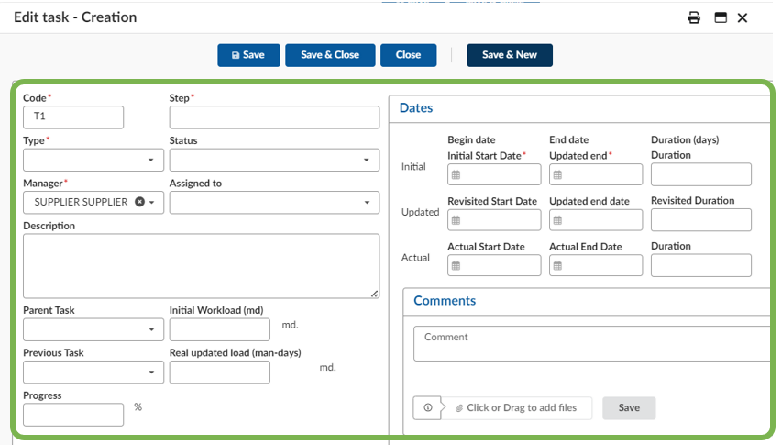
- Click on Save and Close to publish the task or
Click Save and New to publish the task and create a new task.
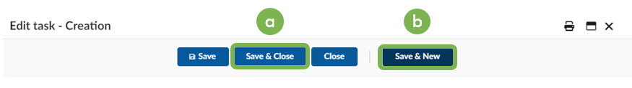
- The workflow tab will display the approval status of various stages of the plan. It also captures the approval history for each step in the workflow.
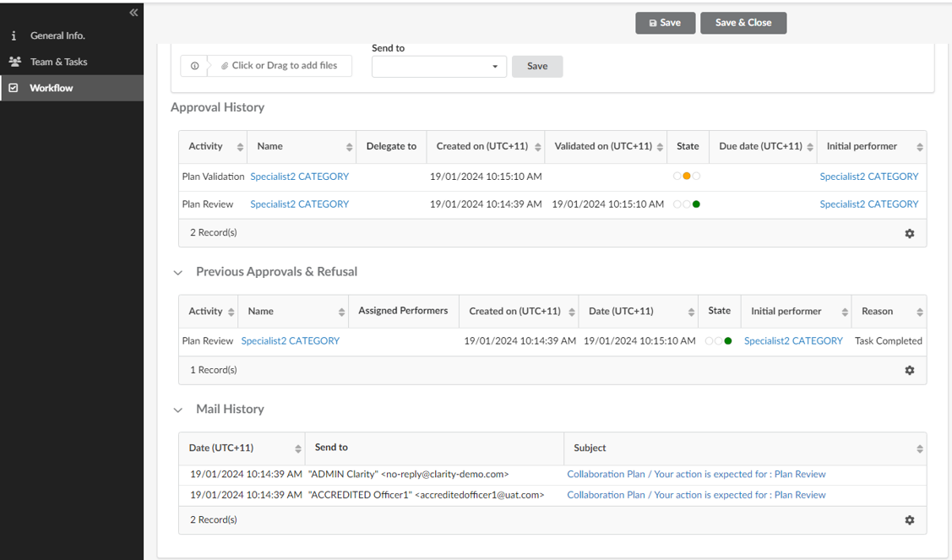
- Click Save and Close when all modifications are completed.
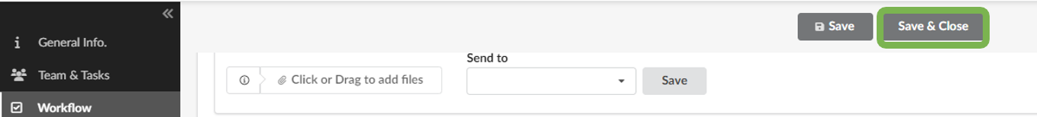

Frequently Asked Questions

Question | Answer
I am seeing some alerts.  What do they mean? | Alerts provide guidance to help you complete actions. There are 2 types of alerts in the portal:  - Blocking alert – will prevent you from completing a task until the alert has been resolved.  - Informational alert – provides guidance but will not block the task from being completed.
Can I resubmit a proposal? | Yes, as long as the RFx is still open and accepting proposals, you can create and submit a new proposal. All proposals will be visible to our team on closure of the Sourcing Event.
What should I do if I forget my password? | Click on Lost your password? on the login screen  to reset your password.
Who to contact for additional help? | Contact Our help desk support via email or phone:  Email: support-sawater@ivalua.com  Tel: +61 272557809

